BioAssay Excel Integration
Functional Specification

Revision History
Date | Revision | Description | Contributors
09/07/2007 | V1 | Initial Draft | Lenny Gutnikov
Jan 23, 2008 | V2 | Draft 2 | Lenny Gutnikov
Jan 25, 2008 | V3 | Draft 3 (Put in format of use-case and detailed work-flow) | Lenny Gutnikov

Revision History 2
1 Summary 5
1.1 Introduction 5
1.2 Requirements 5
1.2.1 Excel Analysis Definition 5
1.2.2 Excel Analysis Execution 5
2 Detailed Solution 7
2.1 File Import Template 7
2.2 File Excel Analysis Definition 7
2.3 Configuration UI 8
2.4 Execution 9
2.5 Uploading .xls File 12
3 Workflow 15

1 Summary

1.1 Introduction
This document contains the functional requirements for BioAssay Excel Integration. Excel This feature is an extension to BioAssay that will integrate Excel to BioAssay. A configuration interface lets the user define an Excel Analysis on a Primary Table. The Configuration UI allows the user to pass data from the Primary, Calculation, Additional, and Summary data tables to Excel. The user may specify how the data is organized when it is passed to Excel. The interface allows the user to specify such things as which data is exported, how it is organized into columns in Excel, their sorting order, and the name of a macro to run once the data is imported into Excel. Additional parameters may be passed for use during the Excel session. The user then executes the Excel Analysis on one or more rows in the Primary Table in which the Excel Integration is defined. This launches an Excel session and runs the user’s macro and/or add-ins on the BioAssay that was passed over. Once the Excel session has ended, the data is sent back and inserted into BioAssay.

1.2 Requirements
- Excel Integration will support Microsoft Office Excel versions 2002, 2003, and 2007.
- Excel Analysis (EA) consists of two steps: definition and execution.

1.2.1 Excel Analysis Definition
- An EA is defined as part of the table definition inside the main protocol definition.
  - A new folder in the protocol definition tree table called “Excel Analyses”
  - New items in this folder representing defined EA’s.
  - New right-click menu items for the protocol definition tree
    - Create new EA
    - Edit existing EA
    - Delete existing EA
- A user interface (UI) to define the EA where the user defines:
  - Name
  - Description
  - Excel workbook to open for EA
  - Name of optional Excel macro to run
  - File Import Template associated with EA
  - Data from which fields to send to Excel
  - The columnar order of this data as it will appear in Excel
  - The sort priority of this data
  - The sort order of this data
  - Any additional name/value parameter pairs to send to Excel

1.2.2 Excel Analysis Execution
- And EA is run from row(s) in a Primary data table in the Data Tab
  - New right-click menu item for Primary data table row(s) called “Run Excel Analysis…”
- A UI that allows the user to select which EA to run.
- This launches Excel and opens the Workbook that was specified in the EA definition.
  - The data that the user chose to send to Excel is placed it sheets and is organized according to the EA definition.
  - Additional parameters that the user specified in the definition are placed in its own sheet.
  - The macro that the user specified in the EA definition is run
  - Any analysis results that the user’s macro performs is placed into a separate sheet in Excel
  - This sheet is then automatically written out as a temporary text file that BioAssay imports using the File Import template in the EA definition.

2 Detailed Solution

2.1 File Import Template
- A File Import Template must be defined and used with the EA.
- This File Import Template will import the results of the EA from a sheet in Excel into BioAssay’s data tables

2.2 File Excel Analysis Definition

- A right-click menu item in the Protocol Definition tree called “New Excel Analysis….”
  - This launches the EA configuration UI and creates a new EA
  - Multiple EA’s may be defined per table and will all appear in this folder
- Once an EA has been defined, it appears in a folder labeled “Excel Analyses” in the Protocol Definition table
- Right-click menu items on each EA in the “Excel Analysis” folder
  - “Edit Excel Analysis” launches the Configuration UI and allows the user to make changes to the EA definition
  - “Delete Excel Analysis” deletes the EA
  - Screenshot: 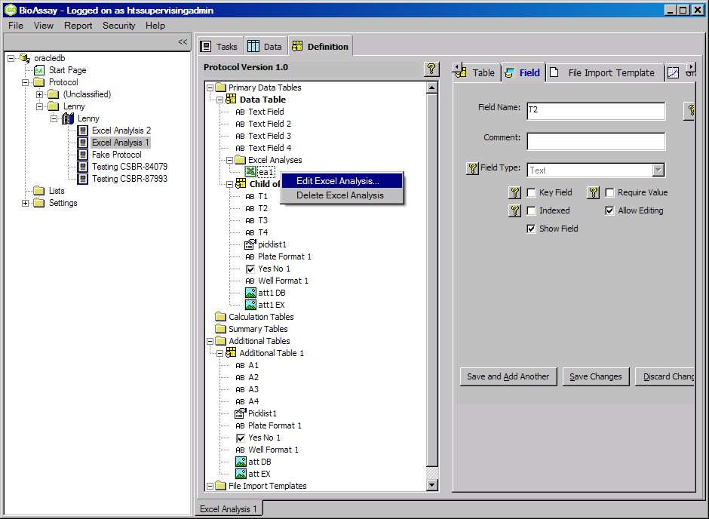

2.3 Configuration UI
- Screenshot: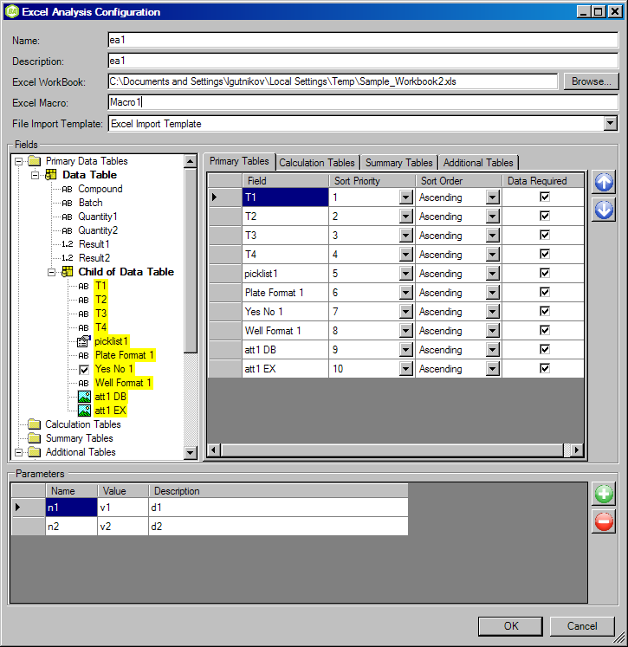
- Name: string (255 characters max). The name of the EA.
- Description: string (4000 characters max). The description of the EA.
- Excel Workbook: string (4000 characters max). The path the .xls Excel workbook file that will be launched with this EA.
  - Clicking the “Browse” button allows the user to navigate to the file
- Macro: string (4000 characters max). The name of the Excel macro to run after the .xls file is opened.
  - If the user does not wish to run a macro, this text box may be left blank
  - If the user does wish to run this macro, it must be spelled here exactly as it is saved in the .xls workbook file
- File Import Template: The File Import Template to use with this EA
  - This File Import Template must be defined before this EA is defined.
  - The list of available File Import Templates in this Protocol Definition will be available in this drop-down menu.
- Selecting Fields:
  - The Protocol Definition tree appears on the left.
  - The user may select a field by clicking on it in the Protocol Definition tree
    - This will highlight them in yellow.
    - It will also add the field as a row item in the appropriate list on the right hand side.
    - For example, if a field from a Primary Table is selected, it will be added in the “Primary Tables” tab. If a field from a calculation table is selected, it will be added in the “Calculation Table” tab, etc.
  - The user may de-select a field by clicking on it again in the Protocol Definition tree
    - This will remove the yellow highlight.
- Organizing fields:
  - Moving row item up: Clicking anywhere on a row in the list of fields in the right-hand side and clicking the blue “up” arrow will move that row up.
  - Moving row item down: Clicking anywhere on a row in the list of fields in the right-hand side and clicking in the blue “down” arrow will move that row down.
  - Sort Priority: Clicking on the “Sort Priority” drop-down will give the user a list of sort priorities. This is a numbered list depending on how many fields are already in the list. Selecting a sort priority will correspondingly change the sort priority of the item that previous had this sort priority. For example, if changing a sort priority from “1” to “5” will change the field that previously had a sort priority of “5” to “1”. When a field is added to the list, it automatically gets the next incremented sort priority.
  - Sort Order: The user can select a sort order for each field. The default is “Ascending”.
- Parameters:
  - To add a parameter, click the green “+” button.
  - To delete a parameter, highlight the parameter(s) and click the red “-“ button.
  - Parameter Name: string (4000 character max)
  - Parameter Value: string (4000 character max)
  - Parameter Description: string (4000 character max)
- “Ok”.
  - Clicking the “Ok” button will create the EA.
  - If any errors are found in the Configuration UI, a red flashing symbol will appear next to the incorrect item. The EA may not be saved unless it is entered correctly.
  - The name of the newly created EA will appear as an item in the “Excel Analysis” folder in the Protocol Definition.
- “Cancel”
  - Clicking “Cancel” will cancel out of the Configuration UI

2.4 Execution
- A right-click menu item on row(s) of a Primary data table called “Run Excel Analysis…”
  - This launches the Excel Analysis Chooser dialog that lets the user choose which Excel Analysis to run
- Screenshot: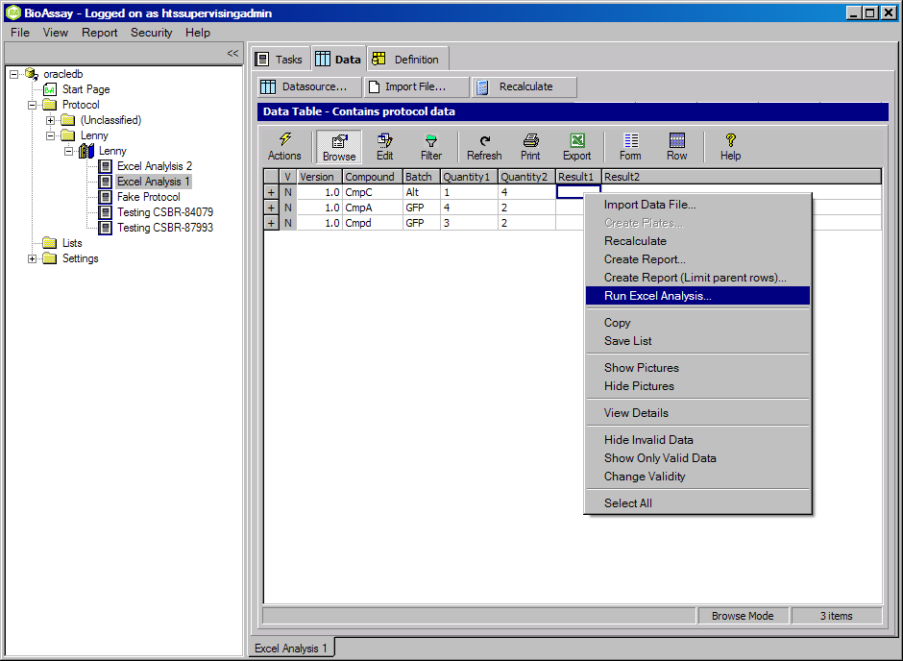
- 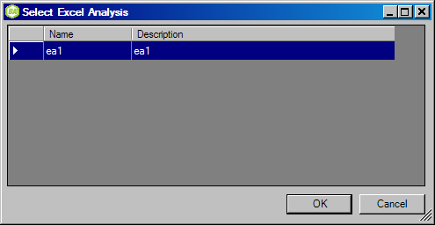
- After clicking on the EA to run, Excel is launched and the various sheets are populated with the data that the user specified to pass to Excel.
- The BioAssay data that is passed to Excel is organized as follows:
  - Data selected from any table in the Primary Table hierarchy will go into a sheet named “BA_P”.
  - Data selected from each of BioAssay’s Calculation Table hierarchies will go into a separate sheet starting with the name “BA_C-“ followed by the name of the top level table.
  - For example, if you have two Calculation Table hierarchies such as
Calc Table 1
Calc Table 2
Calc Table 3
Calc Table 4
Then there will be two sheets named “BA_C-Calc Table 1” and “BA_C-Calc Table 3”
- Data selected from each of BioAssay’s Summary Tables will go into a separate sheet starting with the name “BA_S-“
- For example, if you have two Summary Tables named “Summary Table 1” and “Summary Table 2”, then there will be two sheets named “BA_S-Summary Table 1” and “BA_S-Summary Table 2”
- Data selected from each of BioAssay’s Additional Tables will go into a separate sheet starting with the name “BA_ A-“
For example, if you have two Additional Tables named “Additional Table 1” and “Additional Table 2”, then there will be two sheets named “BA_ A-Additional Table 1” and “BA_ A-Additional Table 2”
- There will be a sheet named “BA_Parameters” that contains parameters passed to Excel from BioAssay. These parameters get defined in BioAssay.
- There will be a sheet named “BA_Analysis_Results” that gets filled with data by running the user’s macro.
- There will be a sheet named “BA_Prompt_Me” with the names of the “Prompt Me” fields that are defined in the BioAssay File Import Template used with this Excel Analysis. It is up to the user to fill in the values for each of these fields.
- Screenshot: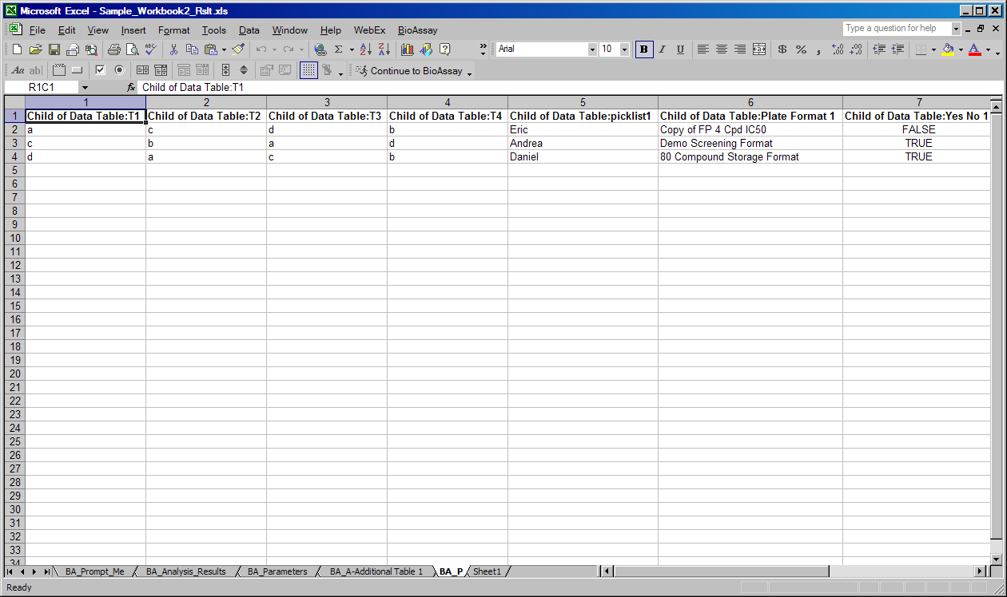
- Verify that the data contained in the various Excel sheets is organized according to the EA definition.
  - Verify that the field columns are in the same order as the list items that appeared in the Configuration UI.
  - Verify that the field columns have been sorted by the same priority as defined in the Configuration UI.
  - Verify that the field columns have the sort order specified in the Configuration UI.
- Verify that the macro ran
  - If the user entered an Excel macro to run, verify that it ran (this will depend on the macro).
- Verify that result have been place in the “BA_Analysis_Results” sheet (this will also depend on the macro and the nature of the EA).
- Verify that the data in the “BA_Analysis_Results” sheet conforms to the format excepted in the File Import Template used with this EA.
  - Screenshot (sample):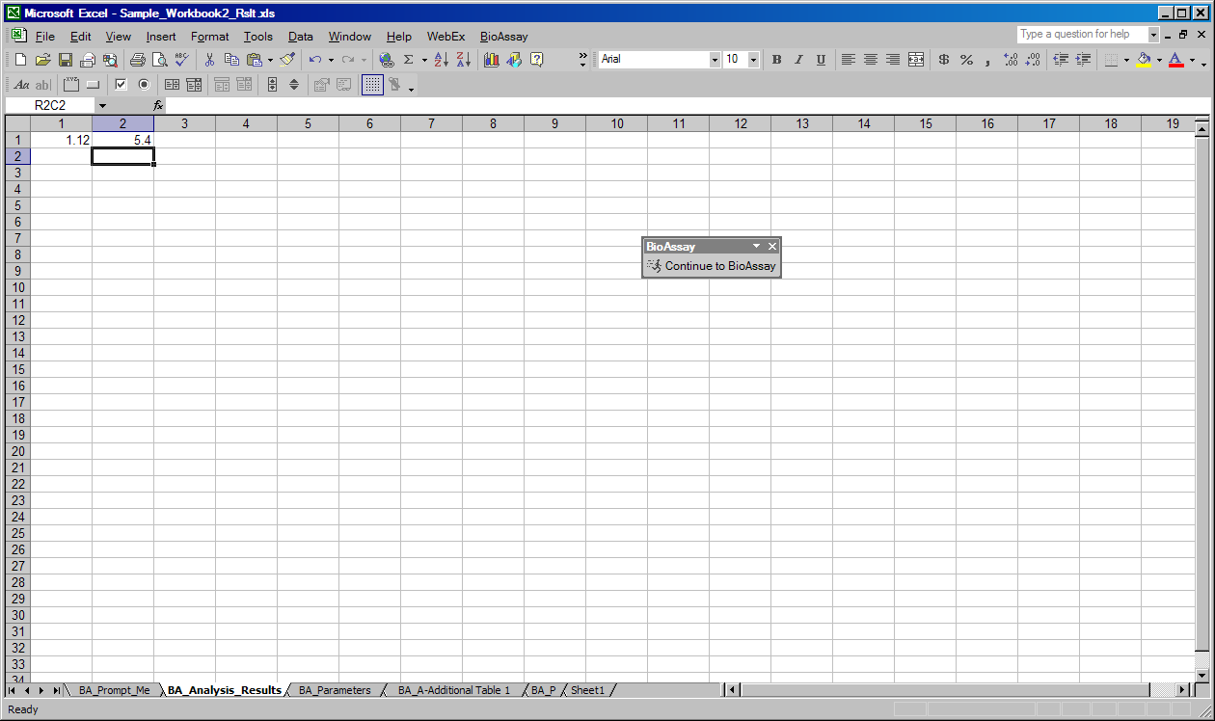
- Continuing with EA: there are three ways to continue the EA and return to BioAssay
  - Manually closing the Excel session.
  - Clicking on the “Continue to BioAssay” toolbar button in Excel.
  - Clicking on the “BioAssay”→”Continue to BioAssay” menu item in Excel.
- BioAssay will then show the file import preview window before importing the data contained in the “BA_Analysis_Results” sheet.

2.5 Uploading .xls File
- The .xls file that was specified in the Configuration UI may be uploaded into a field in BioAssay. The uploaded .xls file will be the resultant file after any changes are made to it during the Excel session part of the EA.
- If you have an Excel Analysis named “Test1”, you need an attachment database storage field named “Test1_Rslt”.
- If you have an Excel Analysis named “Test 2” (with a blank space), you need an attachment database storage field named “Test 2_Rslt”.
- If the rightly named Database Attachment Storage field exists, then the file gets uploaded. If the field isn't found, no upload takes place.
- The naming requirement is case insensitive.
- Only one file gets uploaded per Analysis Run.
- Screenshots (sample): For the protocol below, if you ran the Test1 analysis, you'll see the Test1_Rslt field filled in, in the data tab. If you ran the Test 2 analysis, you'll see the Test 2_Rslt field filled in, in the data tab.
- 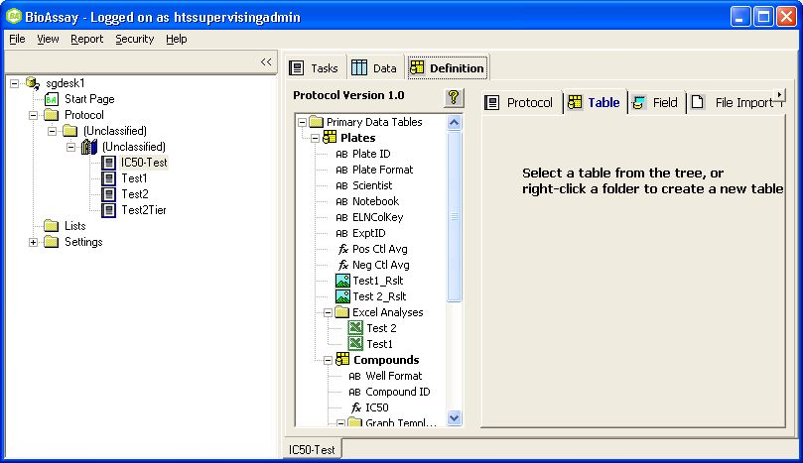
- 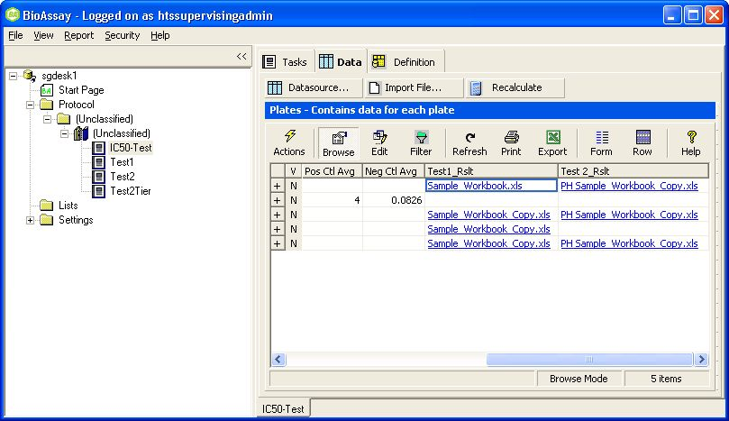

  - Screenshot (sample):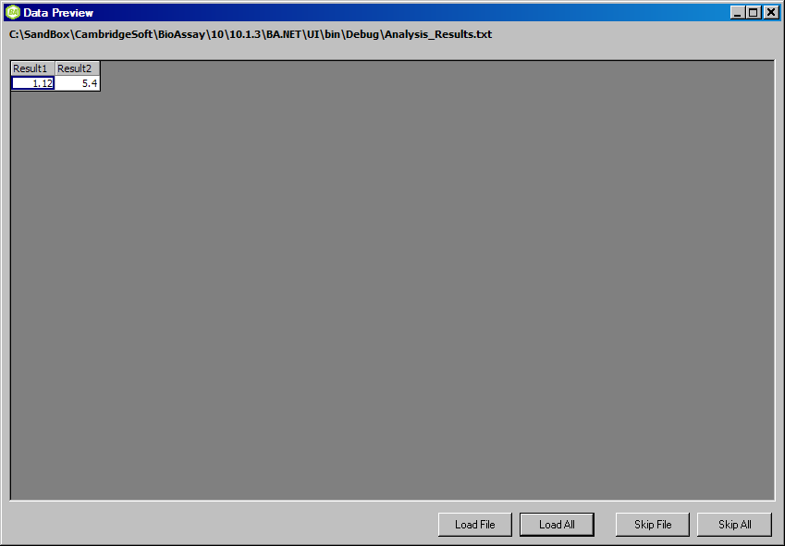
- Click on “Load All” and the results data will be imported into BioAssay
  - Screenshot (sample):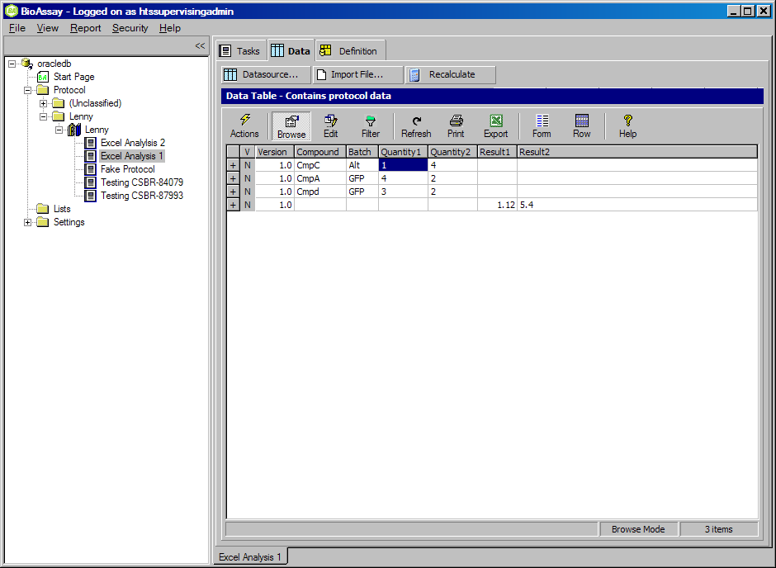

3 Workflow

